**ARYAMAN MISHRA**

**19BCE1027**

**LAB 6**

**Program 1**

library(corrplot)

df=read.csv('C:\\Users\\aryam\\Desktop\\Fall Sem 2021\\Data Visualization Lab\\LAB 6 7-9-21/Loan1.csv')

print(df)

print(ncol(df))

print(nrow(df))

cor(df$NoofLoans,df$GoodLoans,method="pearson")

cor(df$NoofLoans,df$GoodLoans,method="spearman")

cor(df$NoofLoans,df$GoodLoans,method="kendall")

cor.test(df$NoofLoans,df$GoodLoans,method="pearson")

M=cor(df)

print(M)

corrplot(M,method='number',type='upper')

corrplot(M,method='number',type='lower')

corrplot(M,method='number')

corrplot(M,method='circle')

corrplot(M,method='pie')

corrplot(M,method='shade')

corrplot(M,method='color')

corrplot(M,method='ellipse')

corrplot(M,method='square')

**CONSOLE:**

> library(corrplot)

> df=read.csv('C:\\Users\\aryam\\Desktop\\Fall Sem 2021\\Data Visualization Lab\\LAB 6 7-9-21/Loan1.csv')

> print(df)

Age NoofLoans GoodLoans BadLoans GoodRatio BadRatio

1 22 400 390 10 97.5 2.5

2 23 503 480 23 95.4 4.6

3 24 15000 14800 200 98.7 1.3

4 25 2500 2457 43 98.3 1.7

5 26 8000 7763 237 97.0 3.0

6 27 9000 8544 456 94.9 5.1

7 28 7000 6740 260 96.3 3.7

8 29 6000 5700 300 95.0 5.0

9 30 5050 4752 298 94.1 5.9

10 31 6408 6372 36 99.4 0.6

11 32 4568 4493 75 98.4 1.6

12 33 2346 2283 63 97.3 2.7

13 34 500 484 16 96.8 3.2

> print(ncol(df))

[1] 6

> print(nrow(df))

[1] 13

> cor(df$NoofLoans,df$GoodLoans,method="pearson")

[1] 0.9996171

> cor(df$NoofLoans,df$GoodLoans,method="spearman")

[1] 0.9945055

> cor(df$NoofLoans,df$GoodLoans,method="kendall")

[1] 0.974359

> cor.test(df$NoofLoans,df$GoodLoans,method="pearson")

Pearson's product-moment correlation

data: df$NoofLoans and df$GoodLoans

t = 119.81, df = 11, p-value < 2.2e-16

alternative hypothesis: true correlation is not equal to 0

95 percent confidence interval:

0.9986779 0.9998891

sample estimates:

cor

0.9996171

> M=cor(df)

> print(M)

Age NoofLoans GoodLoans BadLoans GoodRatio BadRatio

Age 1.00000000 -0.1499763 -0.1516040 -0.04717977 0.02218187 -0.02218187

NoofLoans -0.14997631 1.0000000 0.9996171 0.62993860 0.12134661 -0.12134661

GoodLoans -0.15160400 0.9996171 1.0000000 0.60820668 0.14577036 -0.14577036

BadLoans -0.04717977 0.6299386 0.6082067 1.00000000 -0.61036205 0.61036205

GoodRatio 0.02218187 0.1213466 0.1457704 -0.61036205 1.00000000 -1.00000000

BadRatio -0.02218187 -0.1213466 -0.1457704 0.61036205 -1.00000000 1.00000000

>

> corrplot(M,method='number',type='upper')

> corrplot(M,method='number',type='lower')

> corrplot(M,method='number')

> corrplot(M,method='circle')

> corrplot(M,method='pie')

> corrplot(M,method='shade')

> corrplot(M,method='color')

> corrplot(M,method='ellipse')

> corrplot(M,method='square')

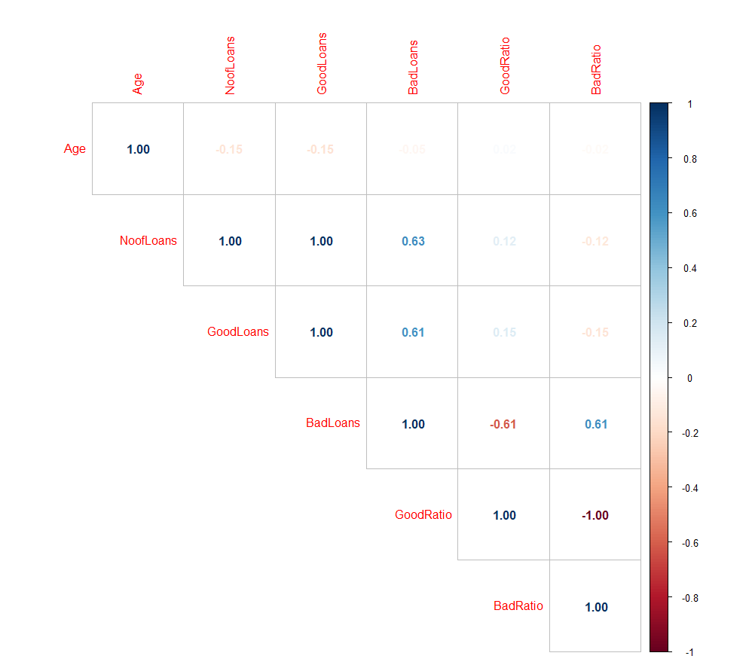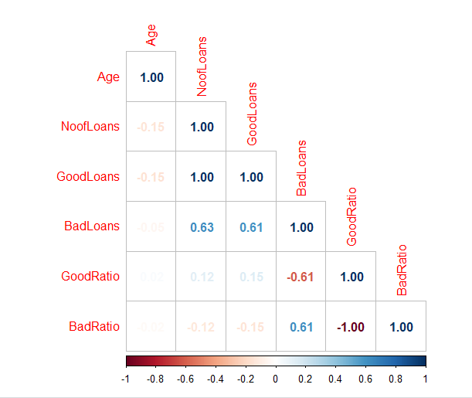

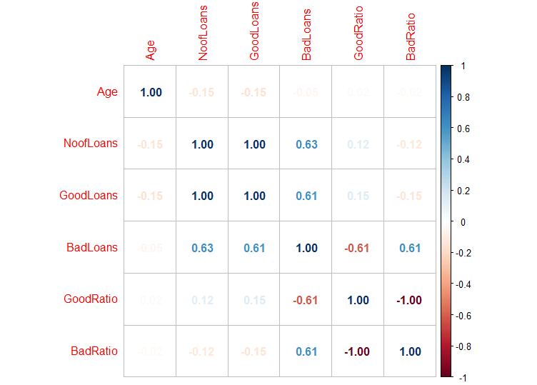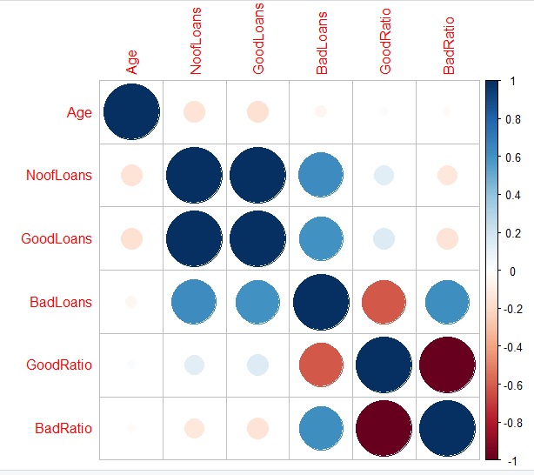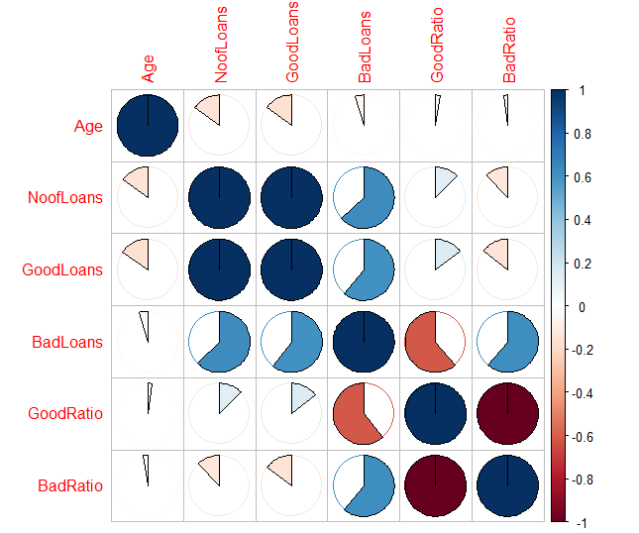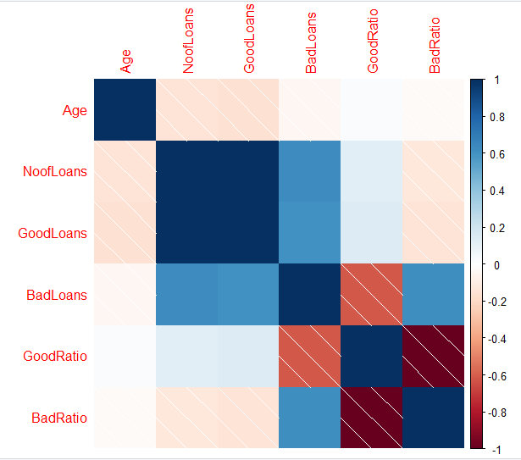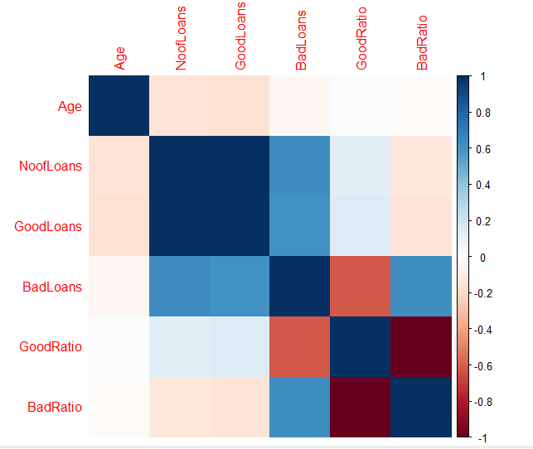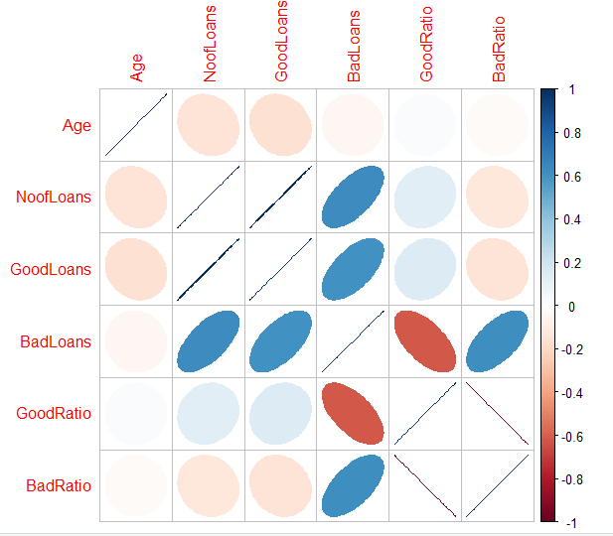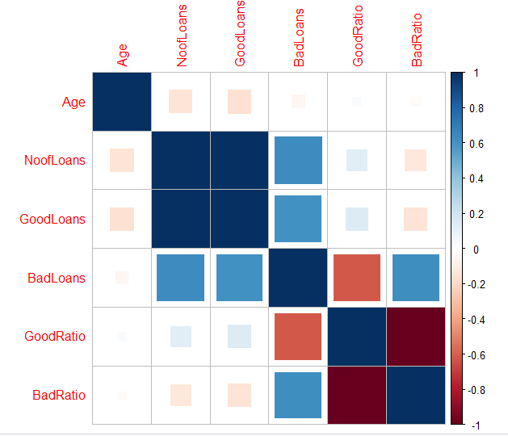

**Program 2**

library(corrplot)

df=read.csv('C:\\Users\\aryam\\Desktop\\Fall Sem 2021\\Data Visualization Lab\\LAB 6 7-9-21/mtcars.csv')

print(df)

print(ncol(df))

print(nrow(df))

cor(df$mpg,df$wt,method="pearson")

cor(df$mpg,df$wt,method="spearman")

cor(df$mpg,df$wt,method="kendall")

cor.test(df$mpg,df$wt,method="pearson")

sapply(mtcars, class)

M=cor(mtcars[sapply(mtcars, function(x) !is.factor(x))])

print(M)

corrplot(M,method='number',type='upper')

corrplot(M,method='number',type='lower')

corrplot(M,method='number')

corrplot(M,method='circle')

corrplot(M,method='pie')

corrplot(M,method='shade')

corrplot(M,method='color')

corrplot(M,method='ellipse')

corrplot(M,method='square')

**CONSOLE:**

> library(corrplot)

> df=read.csv('C:\\Users\\aryam\\Desktop\\Fall Sem 2021\\Data Visualization Lab\\LAB 6 7-9-21/mtcars.csv')

> print(df)

model mpg cyl disp hp drat wt qsec vs am gear carb

1 Mazda RX4 21.0 6 160.0 110 3.90 2.620 16.46 0 1 4 4

2 Mazda RX4 Wag 21.0 6 160.0 110 3.90 2.875 17.02 0 1 4 4

3 Datsun 710 22.8 4 108.0 93 3.85 2.320 18.61 1 1 4 1

4 Hornet 4 Drive 21.4 6 258.0 110 3.08 3.215 19.44 1 0 3 1

5 Hornet Sportabout 18.7 8 360.0 175 3.15 3.440 17.02 0 0 3 2

6 Valiant 18.1 6 225.0 105 2.76 3.460 20.22 1 0 3 1

7 Duster 360 14.3 8 360.0 245 3.21 3.570 15.84 0 0 3 4

8 Merc 240D 24.4 4 146.7 62 3.69 3.190 20.00 1 0 4 2

9 Merc 230 22.8 4 140.8 95 3.92 3.150 22.90 1 0 4 2

10 Merc 280 19.2 6 167.6 123 3.92 3.440 18.30 1 0 4 4

11 Merc 280C 17.8 6 167.6 123 3.92 3.440 18.90 1 0 4 4

12 Merc 450SE 16.4 8 275.8 180 3.07 4.070 17.40 0 0 3 3

13 Merc 450SL 17.3 8 275.8 180 3.07 3.730 17.60 0 0 3 3

14 Merc 450SLC 15.2 8 275.8 180 3.07 3.780 18.00 0 0 3 3

15 Cadillac Fleetwood 10.4 8 472.0 205 2.93 5.250 17.98 0 0 3 4

16 Lincoln Continental 10.4 8 460.0 215 3.00 5.424 17.82 0 0 3 4

17 Chrysler Imperial 14.7 8 440.0 230 3.23 5.345 17.42 0 0 3 4

18 Fiat 128 32.4 4 78.7 66 4.08 2.200 19.47 1 1 4 1

19 Honda Civic 30.4 4 75.7 52 4.93 1.615 18.52 1 1 4 2

20 Toyota Corolla 33.9 4 71.1 65 4.22 1.835 19.90 1 1 4 1

21 Toyota Corona 21.5 4 120.1 97 3.70 2.465 20.01 1 0 3 1

22 Dodge Challenger 15.5 8 318.0 150 2.76 3.520 16.87 0 0 3 2

23 AMC Javelin 15.2 8 304.0 150 3.15 3.435 17.30 0 0 3 2

24 Camaro Z28 13.3 8 350.0 245 3.73 3.840 15.41 0 0 3 4

25 Pontiac Firebird 19.2 8 400.0 175 3.08 3.845 17.05 0 0 3 2

26 Fiat X1-9 27.3 4 79.0 66 4.08 1.935 18.90 1 1 4 1

27 Porsche 914-2 26.0 4 120.3 91 4.43 2.140 16.70 0 1 5 2

28 Lotus Europa 30.4 4 95.1 113 3.77 1.513 16.90 1 1 5 2

29 Ford Pantera L 15.8 8 351.0 264 4.22 3.170 14.50 0 1 5 4

30 Ferrari Dino 19.7 6 145.0 175 3.62 2.770 15.50 0 1 5 6

31 Maserati Bora 15.0 8 301.0 335 3.54 3.570 14.60 0 1 5 8

32 Volvo 142E 21.4 4 121.0 109 4.11 2.780 18.60 1 1 4 2

> print(ncol(df))

[1] 12

> print(nrow(df))

[1] 32

> cor(df$mpg,df$wt,method="pearson")

[1] -0.8676594

> cor(df$mpg,df$wt,method="spearman")

[1] -0.886422

> cor(df$mpg,df$wt,method="kendall")

[1] -0.7278321

> cor.test(df$mpg,df$wt,method="pearson")

Pearson's product-moment correlation

data: df$mpg and df$wt

t = -9.559, df = 30, p-value = 1.294e-10

alternative hypothesis: true correlation is not equal to 0

95 percent confidence interval:

-0.9338264 -0.7440872

sample estimates:

cor

-0.8676594

> sapply(mtcars, class)

mpg cyl disp hp drat wt qsec vs am gear carb

"numeric" "numeric" "numeric" "numeric" "numeric" "numeric" "numeric" "numeric" "numeric" "numeric" "numeric"

> M=cor(mtcars[sapply(mtcars, function(x) !is.factor(x))])

> print(M)

mpg cyl disp hp drat wt qsec vs am gear carb

mpg 1.0000000 -0.8521620 -0.8475514 -0.7761684 0.68117191 -0.8676594 0.41868403 0.6640389 0.59983243 0.4802848 -0.55092507

cyl -0.8521620 1.0000000 0.9020329 0.8324475 -0.69993811 0.7824958 -0.59124207 -0.8108118 -0.52260705 -0.4926866 0.52698829

disp -0.8475514 0.9020329 1.0000000 0.7909486 -0.71021393 0.8879799 -0.43369788 -0.7104159 -0.59122704 -0.5555692 0.39497686

hp -0.7761684 0.8324475 0.7909486 1.0000000 -0.44875912 0.6587479 -0.70822339 -0.7230967 -0.24320426 -0.1257043 0.74981247

drat 0.6811719 -0.6999381 -0.7102139 -0.4487591 1.00000000 -0.7124406 0.09120476 0.4402785 0.71271113 0.6996101 -0.09078980

wt -0.8676594 0.7824958 0.8879799 0.6587479 -0.71244065 1.0000000 -0.17471588 -0.5549157 -0.69249526 -0.5832870 0.42760594

qsec 0.4186840 -0.5912421 -0.4336979 -0.7082234 0.09120476 -0.1747159 1.00000000 0.7445354 -0.22986086 -0.2126822 -0.65624923

vs 0.6640389 -0.8108118 -0.7104159 -0.7230967 0.44027846 -0.5549157 0.74453544 1.0000000 0.16834512 0.2060233 -0.56960714

am 0.5998324 -0.5226070 -0.5912270 -0.2432043 0.71271113 -0.6924953 -0.22986086 0.1683451 1.00000000 0.7940588 0.05753435

gear 0.4802848 -0.4926866 -0.5555692 -0.1257043 0.69961013 -0.5832870 -0.21268223 0.2060233 0.79405876 1.0000000 0.27407284

carb -0.5509251 0.5269883 0.3949769 0.7498125 -0.09078980 0.4276059 -0.65624923 -0.5696071 0.05753435 0.2740728 1.00000000

> corrplot(M,method='number',type='upper')

> corrplot(M,method='number',type='lower')

> corrplot(M,method='number')

> corrplot(M,method='circle')

> corrplot(M,method='pie')

> corrplot(M,method='shade')

> corrplot(M,method='color')

> corrplot(M,method='ellipse')

> corrplot(M,method='square'**)**

